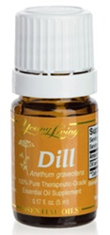

Dill Essential Oil
Dill (Anethum graveolens) oil has a spicy, fresh scent that is stimulating, revitalizing, and balancing. Use dill essential oil for cooking or preparing
food to enhance flavor. Dill has an approximate ORAC of 356,444 (TE/L). TE/L is expressed as micromole Trolox equivalent per liter.

