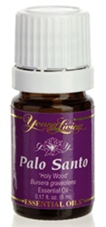

Palo Santo Essential Oil
Palo santo (Bursera graveolens) comes from the same botanical family (Burseraceae) as frankincense, although it is found in South America
rather than the Middle East. Like frankincense, palo santo is known as a spiritual oil, traditionally used by the Incas to purify and cleanse the
spirit from negative energies. Even its Spanish name reflects how highly this oil is regarded: Palo santo means "holy wood" or "sacred wood."

